Systematic Literature Review
Determinants of Health Outcomes

Summary
Over the last decades, a growing amount of research suggests that medical care is not the sole determinant of health outcomes. Rather, social determinants of health (SDH) play a large role in shaping health outcomes (Braveman & Gottlieb, 2014). The definition for social determinants of health is given by the WHO commission on the Social Determinants of Health: “The conditions in which people are born, grow, live, work, and age, and the fundamental drivers of these conditions” (Marmot et al., 2008). In the 21st century, most scholars agree that social determinants of health are of upmost importance for health outcomes. However, there is less agreement on how much different social determinants influence health outcomes, and how policymakers should adapt to different health-promoting or health-damaging pathways (Braveman et al., 2011). ` The overall conclusion of the research is that people who are less advantaged in terms of socioeconomic position, have worse health and shorter lives compared to people with a better socioeconomic position. This phenomenon is referred to as the social gradient of health. This concept was made famous by the “Whitehall studies of British civil servants” in the United Kingdom, which found that people in lower employment grades had higher rates of mortality and morbidity through various illnesses, even though all participants had access to the same healthcare system (Marmot et al., 1991). This research underscores that factors outside of medical care are significant determinants of health outcomes. Another often cited example is the health expenditure of the United States. Even though the US is the top spender per capita on medical care, yet it traditionally ranks low on international comparative health rankings (Braveman & Gottlieb, 2014).
Social Determinants of Health
The social determinants of health can be broken down into three subcategories, the socio-economic determinants, the psychosocial risk factors, and the community and societal characteristics (Ansari et al., 2003). Firstly, the socio-economic determinants are the most influential determinants for health outcomes. These determinants include factors such as age, income, race, ethnicity, education, employment, and housing. Secondly, the psychosocial risk factors include factors such as poor social networks, depression, anxiety, and stress (Ansari et al., 2003). Especially severe stress is linked to poor health outcomes in various studies (Garfin et al., 2018; Taylor, 2010). Lastly, community and societal characteristics are identified as a health determinant, which include factors such as poverty, crime rate, income inequality, trust in social institutions, and tolerance of diversity. These components of the social determinants of health influence each other as well as health outcomes.

Behavior

Behavior is often identified as a key health determinant. Behavior in this context refers to the lifestyle choices and daily habits that affect health outcomes. Commonly researched behaviors include smoking, diet and nutrition, physical exercise, alcohol and substance use, sleep habits, and sexual activity. Moreover, it is often referred to as a modifiable determinant, meaning that people, at least in theory, can change their behavior in order to ensure better health outcomes (Daw et al., 2017). However, behavior is often shaped by ones physical and social environment. For example, there is a correlation between smoking and unemployment rates (Janlert, 1997; Kaiser et al., 2018). Various pathways linking behavioral determinants to health outcomes have been widely studied, such as how dietary habits influence the risk of developing conditions such as diabetes, cardiovascular diseases and obesity (Jiao, 2024).
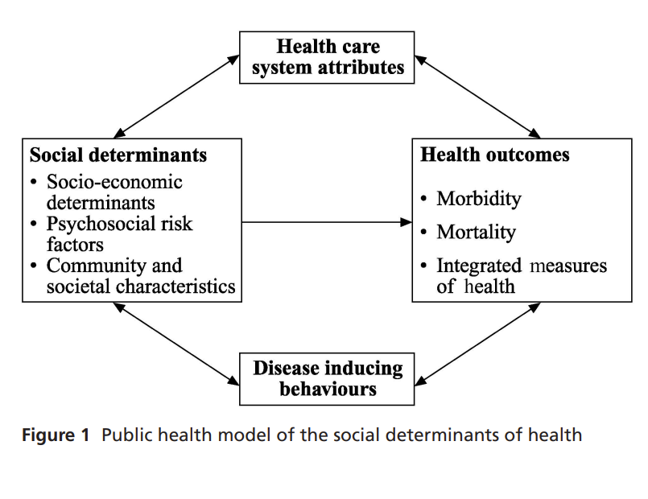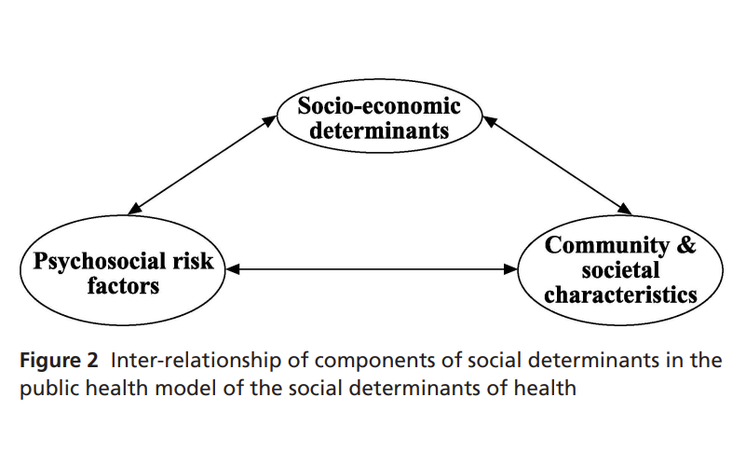

References

Ansari, Z., Carson, N. J., Ackland, M. J., Vaughan, L., & Serraglio, A. (2003). A public health model of the social determinants of health. Sozial-und Präventivmedizin/Social and Preventive Medicine, 48, 242-251.
Braveman, P., Egerter, S., & Williams, D. R. (2011). The social determinants of health: coming of age. Annual review of public health, 32(1), 381-398.
Braveman, P., & Gottlieb, L. (2014). The social determinants of health: it's time to consider the causes of the causes. Public Health Rep, 129 Suppl 2(Suppl 2), 19-31. https://doi.org/10.1177/00333549141291s206
Daw, J., Margolis, R., & Wright, L. (2017). Emerging adulthood, emergent health lifestyles: Sociodemographic determinants of trajectories of smoking, binge drinking, obesity, and sedentary behavior. Journal of health and social behavior, 58(2), 181-197.
Garfin, D. R., Thompson, R. R., & Holman, E. A. (2018). Acute stress and subsequent health outcomes: A systematic review. Journal of psychosomatic research, 112, 107-113.
Janlert, U. (1997). Unemployment as a disease and diseases of the unemployed. Scandinavian journal of work, environment & health, 79-83.
Jiao, L. (2024). Social Determinants of Health, Diet, and Health Outcome. In (Vol. 16, pp. 3642): MDPI.
Kaiser, M., Reutter, M., Sousa-Poza, A., & Strohmaier, K. (2018). Smoking and local unemployment: evidence from Germany. Economics & Human Biology, 29, 138-147.
Marmot, M., Friel, S., Bell, R., Houweling, T. A., & Taylor, S. (2008). Closing the gap in a generation: health equity through action on the social determinants of health. The lancet, 372(9650), 1661-1669.
Marmot, M. G., Smith, G. D., Stansfeld, S., Patel, C., North, F., Head, J., White, I., Brunner, E., & Feeney, A. (1991). Health inequalities among British civil servants: the Whitehall II study. Lancet, 337(8754), 1387-1393. https://doi.org/10.1016/0140-6736(91)93068-k
Taylor, S. E. (2010). Mechanisms linking early life stress to adult health outcomes. Proceedings of the National Academy of Sciences, 107(19), 8507-8512.

